UPPWISE INDIA

www.uppwise.com



**Quaterly Development Planning**

**Q1-2024**

**Feature: Add Column to Document Register and Workspace Document Widget**

**Feature Title:**

Add Column to Document Register and Workspace Document Widget

**Priority:**

Medium

**Submitted By:**

SPM

**Target Users:**

Standard – Customer: AXA

**Feature Description:**

This feature aims to enhance the document management capabilities within the teamspace environment by introducing a new column titled "Files." This column will display the files that are attached to each document listed in the document register and within the document widget in the workspace.

**Acceptance Criteria:**

**Document Register Updates:**

* When viewing the document register within a teamspace, a new column titled "Available Files" should be displayed alongside existing columns.
* For each document listed in the register, the "Files" column should indicate the files that are attached to that particular document.
* Clicking on the file name in the "Files" column should open the respective file and which contains multiple file that will show under the popup.

**Document Widget Updates:**

* Within the workspace document widget, a new column titled " Files" should be added.
* The "Files" column should display the files attached to each document listed in the widget.
* Users should be able to interact with the files listed in the “Files" column, by opening a popup which contains all the respective files.

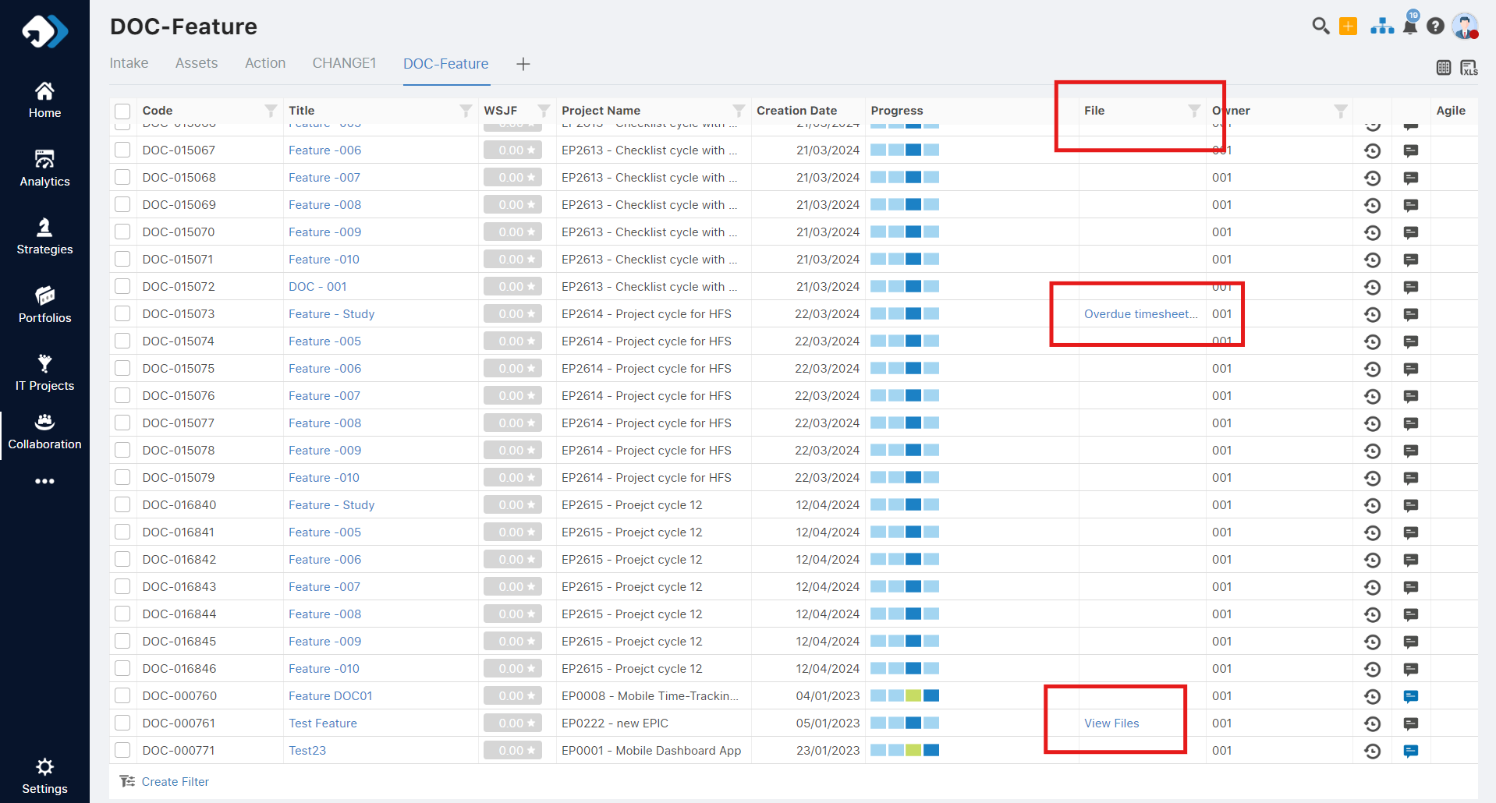

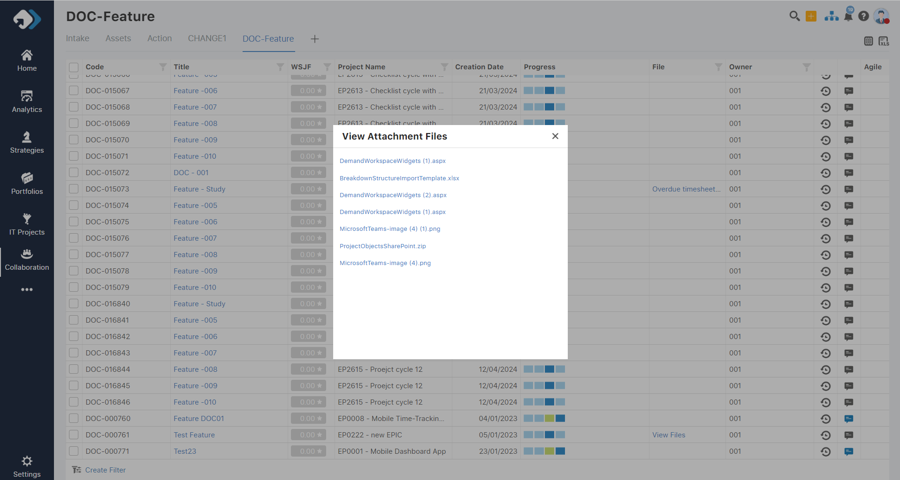

**Note**: Same kind of implementation can go over the Document widget under the workspace